Quiz : Evolution Name_________________________Date_______

___1) Eukaryotes are thought to have come from a prokaryotic cell that was ingested or invaded another prokaryotic cell. These cells continued to live as a single organism. This is part of the :
A) Theory of evolution C) Theory of Spontaneous Generation
B) Theory of Endosymbiosis D) Theory of Natural Selection

___2) “Acquired Traits” are characteristics that an organism obtains as a result of a need for that trait. Which scientist is credited with the formation of the concept of acquired traits as a mechanism for evolution?
A) Lamarck B) Darwin C) Mendel D) Malthus

___3) On a newly formed island, most of the food is in the form of hard shelled nuts. Birds have been coming to the island to get food. Over time the birds with the small & medium sized beaks have died out and now only the birds with the large sized beaks are living on the island. This is an example of:
A) stabilizing selection C) disruptive selection
B) directional selection D) genetic drift

___4) Recently a group of frogs were discovered in the American Rocky Mountains. It is believed that these frogs are close relatives of the smokey mountain chicken frog. What would be the most helpful to look at in determining the relationship between the 2 frog species?
A) morphology B) anatomical structures C) what the frogs eat D) DNA

___5) While looking at some snails in an pond ecosystem, a student noticed that the snails had very similar shaped shells but they were different colors & sizes. The lighter colored snails were larger & lived near the surface and the dark snails were smaller & found at the bottom of the pond. These are 2 different species of snails but it is possible that the snails had a common ancestor. These snails would be an example of:
A) coevolution B) divergent evolution C) convergent evolution D) none of these

___6) Humans breed dogs to have specific traits. The different breeds of dogs are becoming more different from other breeds. This is an example of how artificial selection causes:
A) disruptive selection B) directional selection C) stabilizing selection D) divergent evolution

___7) The theory that organisms have new traits that their ancestors did not have:
- Acquired traits
- Descent with modification
- Homologous structure
- All of these

___8) The picture below demonstrates:
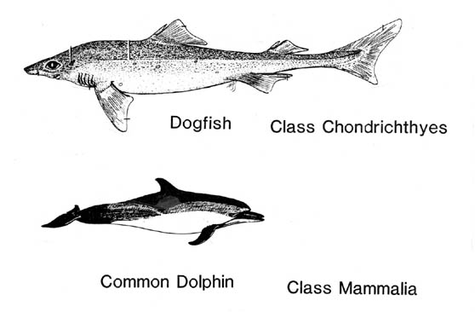
- Coevolution B) Convergent evolution C) Divergent evolution D) Punctuated equilibrium

___9) In a particular environment having very large feet is an advantage over having medium or very small feet. This demonstrates:
- Stabilizing selection
- Disruptive selection
- Extreme selection
- Directional selection

___10) The man who proposed natural selection as the mechanism for evolution:
- Darwin B)Mendel C)Watson D)Redi

___11) Which of the following would NOT disrupt genetic equilibrium?
A) random mating B) genetic drift C) immigration D) natural selection

___12) Which of the following is most likely to disrupt any genetic equilibrium that may exist in a population.
A) mutations B) competition C) convergent evolution D) lack of resources

___13) When 2 or more species evolve in response to each other:
- Coevolution B)Convergent evolution C)Divergent evolution D)Punctuated equilibrium

